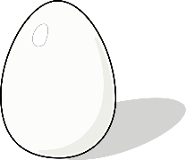OPERATION EGG DROP

**THE CHALLENGE:**

Using only the materials on the list, your task is to design a device capable of protecting an egg (passenger) from a 22m fall and save as much money as possible when constructing your design.

**MATERIALS:**

You will be allowed to use only the materials below for constructing your device. They all have a price and a maximum quantity you may purchase. Anything you purchase **must** be used and may not be wasted – so spend wisely!

Try to spend as little money as possible on your design so you can maximise your profits.

|  |  |  |
| --- | --- | --- |
| **MATERIAL** | **COST** | **MAXIMUM AMOUNT** |
| ***Egg (Passenger)*** | ***Will pay $50 for the flight*** | |
| String | $2 for 30cm | 120cm ($8) |
| Masking Tape | $4 for 20cm | 80cm ($16) |
| Paper cup | $3 per cup | 2 cups ($6) |
| Drinking Straws | 50c per straw | 20 straws ($10) |
| A4 Paper | $2 per sheet | 2 Sheets ($4) |
| 1 egg carton cup | $2 per cup | 2 cups ($4) |
| 1 sheet of paper towel | $1 per piece | 3 pieces ($3) |
| 1 sheet of coloured tissue paper | $2 per piece | 3 pieces ($6) |
| Cotton balls | 50c per ball | 8 balls ($4) |
| Bubble wrap | $3 per square (15cmx15cm) | 2 squares ($6) |

**DIRECTIONS:**

Before collecting the necessary materials, engineers spend a great deal of time thinking, planning and drawing their ideas as part of their blueprints. Use the next page to create a blueprint drawing of your idea.

It is important to label all parts of your design and include a list of all the materials you used, how much of it you used, as well as an estimate of how much your device would cost to build. Remember to consider cost efficiency as well as a quality product that surrounds and protects the egg when dropped. The device that survives the fall and costs the least to build will be declared the winner!

**INDIVIDUAL PLANNING:**

**Directions:** Use the space below to plan and draw your egg drop device.

Be sure to consider what forces must be overcome to successfully protect the egg from the fall without having it break. Also consider cost and use of materials.

Don’t be afraid to think outside the box!

|  |  |  |
| --- | --- | --- |
| **Material** | **Quantity** | **Cost** |
|  |  |  |
|  |  |  |
|  |  |  |
|  |  |  |
|  |  |  |
|  |  |  |
|  |  |  |
|  |  |  |
| **Total Cost** | |  |

**Explanation:** Provide some support/reasons for the design choices you have made: ________________________________________________________________________________________________________________________________________________________________________________________________________________________________________________________________________________________________________________________________________________________________________________________________________________________________________________________________________________________________________________________________________________________________________________________________________________________________________________________________________________________________________________________________________________

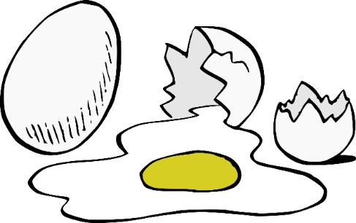

**TESTING:**

Go out and test your design.

After the first egg drop, answer the following questions:

1. Describe what part(s) of your device worked as expected:

________________________________________________________________________________

________________________________________________________________________________________________________________________________________________________________________________________________________________________________________________

2. Identify at least 1 part of your device that did not work perfectly and explain why it was unsuccessful. ________________________________________________________________________________________________________________________________________________________________________________________________________________________________________________________________________________________________________________________________

3. Think about the projects that were successful and describe in detail at least 2 ideas you observed that helped to protect the egg.

________________________________________________________________________________________________________________________________________________________________________________________________________________________________________________________________________________________________________________________________

Write down any modifications and additional materials you will need to purchase for the final egg drop.

|  |  |  |
| --- | --- | --- |
| **Material** | **Quantity** | **Cost** |
|  |  |  |
|  |  |  |
|  |  |  |
|  |  |  |
|  |  |  |
|  |  |  |
|  |  |  |
|  |  |  |
| **Total Cost** | |  |

|  |  |  |
| --- | --- | --- |
| **Material** | **Quantity** | **Cost** |
|  |  |  |
|  |  |  |
|  |  |  |
|  |  |  |
|  |  |  |
|  |  |  |
|  |  |  |
|  |  |  |
| **Total Cost** | |  |

**PARTNER PLANNING**

**Combined Ideas –** Now that you have a partner to work with, you need to listen to each other and share ideas. Use the space below to draw the device you both agree to construct. Complete the table of materials you think you will need and predict the total cost of your device.

**PRE-TEST REFLECTIONS**

**Directions:** Answer these questions with your partner before you perform your first test drop.

1. Explain the purpose of each material you used in your design (e.g.: how it will help to protect the egg).

|  |  |
| --- | --- |
| **Material Used** | **Purpose** |
|  |  |
|  |  |
|  |  |
|  |  |
|  |  |
|  |  |

2. Explain the reasoning behind how your design is supposed to work:

________________________________________________________________________________________________________________________________________________________________________________________________________________________________________________________________________________________________________________________________________________________________________________________________________________________________________________________________________________________________